Mangalyaan: Truly Indian  
- Aman Garg, BVCOE

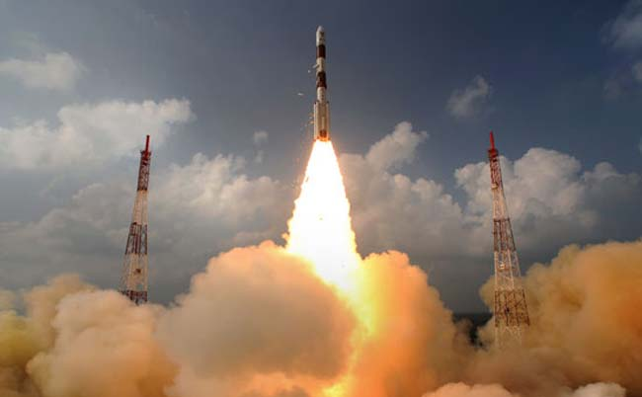

“Indian Mars orbiter reaching Mars at the cost of Rs. 12 per kilometer”  
 *12 Rupees per kilometer?* I almost presumed Indians have assembled a flying auto-rickshaw when I first learned about Mangalyaan.  
  
India's first Mars orbiter, popularly and officially known as ‘Mangalyaan’, witnessed its much anticipated launch with Polar Satellite Launch Vehicle-C25 (PSLV C-25) on 5 November 2013 from Sriharikota launch pad, and is expected to reach its destination orbit on 14 September, 2014. The ISRO space probe started its nine-month 400 million kilometer long odyssey towards the red planet to look for the presence of Methane in Martian atmosphere. The cost of the project is $72.9 million (about Rs. 450 Crores) which is approximately and surprisingly costing just Rs. 12 km per hour! Success of this mission is definitely expected to establish an Asian hegemony of India in the aerospace domain.

**Objective and Minutiae**

According to Indian scientists it’s the showcase of Indian technology in the form of an attempt to study space conditions beyond Earth’s orbit. Once into the Mars orbit, the 1.3-tonne orbiter will attempt to capture concrete details of climate, geological conditions and evidence of water, with thermal infrared sensors. Five scientific instruments that have been deployed on board will help to ascertain any sign of life on the planet. With its successful launch, India becomes the sixth nation to be heading towards the red planet.  
  
 **Point of Criticism**

Although the mission cost is cheap according to the standard of a developed country, implementation of the mission has gone through severe condemnation in India itself. Economists and social activists have criticized the amount of money spent on this mission, questioning the negligence to problems of food resources, clean water and poor sanitation persisting in the country. Some space research scientists have also argued with ISRO that the focus should have been on developing new satellites for commercial sector.  
  
In the words of an ISRO Spokesperson, “The primary goal is the technical demonstration. This will help us by advancing our existing technology in communications and Earth observation satellites. We hope it will also inspire younger minds.”  
  
Having that said, the ‘flying auto-rickshaw’ of India seems to offer a promising future for the country in space exploration.

